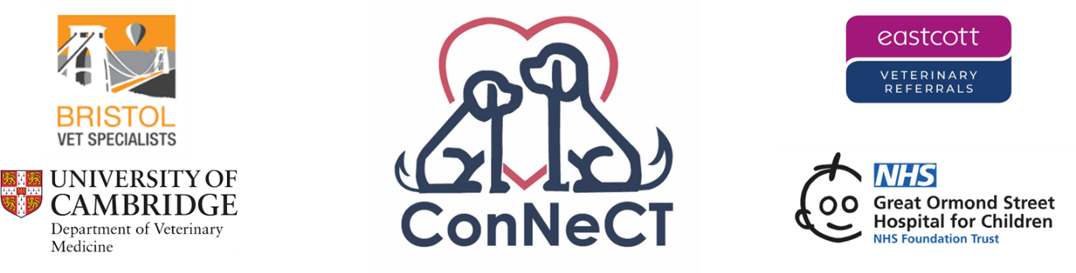

**Owner Information Sheet**

**Study title**: Prevalence of **Con**genital Heart Disease in **Ne**onatal Puppies Experiencing Unexplained Death, Diagnosed by Micro-**CT**: The ConNeCT Study

**Study contact**: Caroline Cutler: [puppyhearts2025@gmail.com](mailto:puppyhearts2025@gmail.com)

This study is a collaboration between Bristol Vet Specialists, the University of Cambridge, Eastcott Veterinary Referrals and Great Ormond Street Institute for Child Health. Thank you for considering submitting your puppy for inclusion in our study. Please accept our condolences for your loss. If you are struggling with pet bereavement, please do consider visiting <https://www.bluecross.org.uk/pet-bereavement-and-pet-loss>, or calling **0800 096 6606** for support.

What is the purpose of the study?

Sadly, unexplained death of puppies under 4-weeks-old is not uncommon. The phenomenon is commonly referred to as ‘fading puppy syndrome’, but we rarely understand the cause of this upsetting loss. In children, a common cause is heart disease, but many cases are detected by maternal ultrasound before birth, so can be avoided. This is not possible in dogs, and so we suspect that a high number of puppy deaths relate to the heart. The aim of our study is to screen for heart disease in these puppies, in order to better understand puppy loss, and begin the process of trying to help minimise the problem for dogs.

What will happen to my puppy’s remains?

Although this consideration may be upsetting, it is important for you to know our approach to this study. Your vet will carefully remove the heart and lungs of the puppy post-mortem. These will be preserved, and sent on to our specialist centre for processing and a high-definition CT scan. The puppy’s body can either be sent on for cremation by your local vets, or returned to you for home burial, as you wish.

Imaging CT analysis

Tissue samples will undergo micro-CT scanning, to create a 3D computerised image of the heart. Our team of specialist cardiologists will then analyse these scans to determine if heart disease was present. You will be sent a report, via your local vets, so that you can understand the potential impact on any future breeding.

What will happen to the tissue sample afterwards?

Samples will be retained in a medical library for 5-years after study completion.

Confidentiality

Security of your data is important to us. Your information will not be shared with any third parties. When your local vets enrol your puppy’s sample in this study, they will ask you to sign a specific consent form. Your form will not contain any personal information other than your surname. We will receive information from your vet regarding your puppy’s age at the time of death, breed, sex, and whether they were delivered by Caesarean section. A digital copy will be stored securely, in a password protected file, and the paper copy destroyed. Study samples will be allocated an anonymous reference number, so even your surname and vet practice details will not be accessible anywhere else. The reference number will be used for all future databases, but mean that samples can be traced back to you in order to provide you with a report once the specialist imaging study has been completed.

What will we do with the results?

The results of our study will be presented at an international veterinary conference and written up in a scientific journal for wider dissemination to the veterinary community. Our aim is to begin to better understand heart disease in young dogs, to try and prevent future disease on a large scale.

Financial implications

Enrolling your puppy’s heart in our study will not incur any costs for you. If your vet requests payment for heart and lung extraction, then please ask them to contact us before they proceed.

What if I have any questions?

We are happy to answer any questions you might have about inclusion in this study; please email us on [puppyhearts2025@gmail.com](mailto:puppyhearts@gmail.com) to get in touch.

What if I change my mind?

If you decide to withdraw your participation from the study after a tissue sample from a puppy is enrolled, you can do so for up to 1-year. Please email us to discuss things. Sadly, because of the preservative used for storing tissue samples, they cannot be returned to owners after submission. Your participation is your right, and we will respect any decisions made.