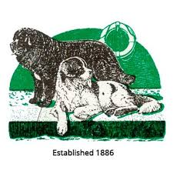
The Newfoundland Club
Welfare Helpers Form
Welfare rely on the generosity of members in giving up their time to assist with the running of our activities – if you can assist please provide details below.
Your generosity is appreciated!

Name(s):

Address:

Telephone Number(s):

Email Address:

Date:

Are you currently a member of the Newfoundland Club? (we regret that for insurance purposes we are only able to enlist the help of Club Members)

Please provide as much detail as possible in the following sections (where appropriate expenses will be payable):
Transport: Are you able to assist with the transport of Newfoundlands? (This may include collecting dogs when they are surrendered to the Newfoundland Club and transporting them to their new homes or foster carer). Please provide details including geographic area and or mileage you are willing to undertake:

Fostering/Kenneling: Are you able to provide kenneling or home care for a Newfoundland on a temporary basis? Please provide details including facilities available:

Home Visiting: Are you able to visit potential homes for Newfoundlands coming in to Welfare to assist in assessing their suitability and to advise of the kind of dog most appropriate? Please provide details including geographic area/mileage you are willing to undertake:

Please provide details of any other assistance you can offer:

Please return this form by email to: welfare@thenewfoundlandclub.co.uk or by post to;

Mrs. Helen Gray
Orchard Cottage
The Street
Worth
Deal
Kent
CT14 0BY

