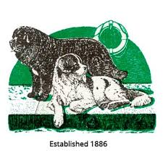
The Newfoundland Club
Expression of Interest in Adopting a Welfare Dog
If you are interested in adopting a Welfare Dog, please read the information on our web site before completing this form.
The Welfare Coordinator will contact you within two weeks of receipt of the form to discuss the process with you. If you decide you wish to proceed you will be required to make a payment of £10 to Newfoundland Welfare (this goes towards the cost of caring for dogs taken in to our care):
Name(s):
Address:

Contact Telephone Number(s):

What is the best time of day to contact you?:

Email Address:
Further Details (please provide brief information regarding the kind of dog you are looking for and your experience with dogs to date):

Date:
Please return the completed form by email to welfare@thenewfoundlandclub.co.uk or by post to;
Mrs. Helen Gray
Orchard Cottage
The Street
Worth
Deal
Kent
CT14 0BY

